**CS 480 - Introduction of Artificial Intelligence**

**Written Assignment 2**

Rutul Rajeshkumar Mehta

(A20476293)

***Answer - 1***

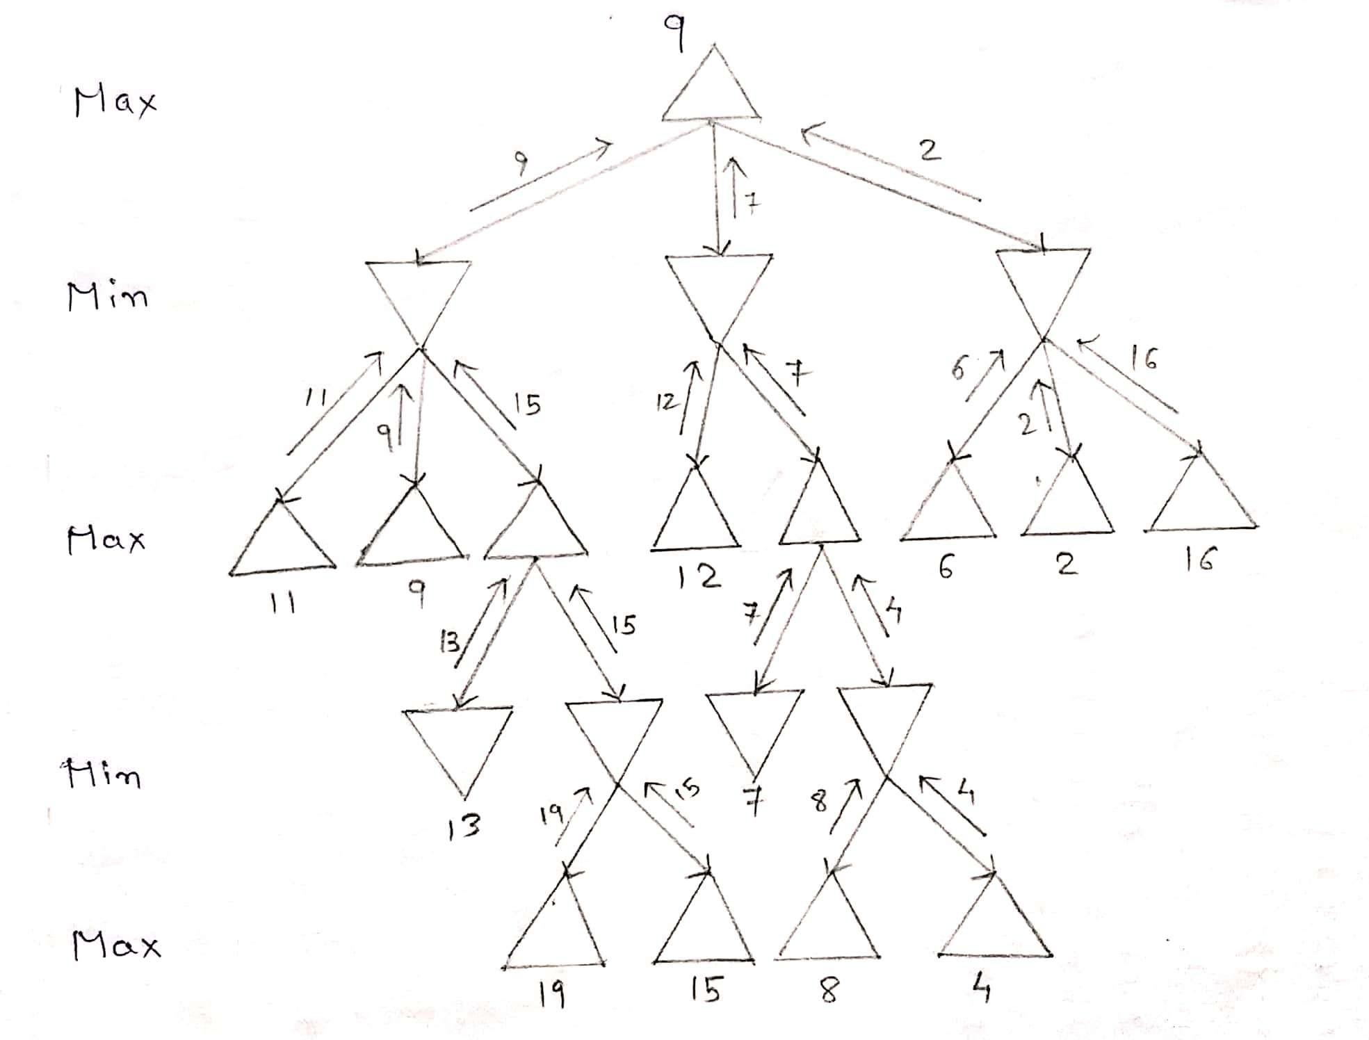

***Answer - 2***

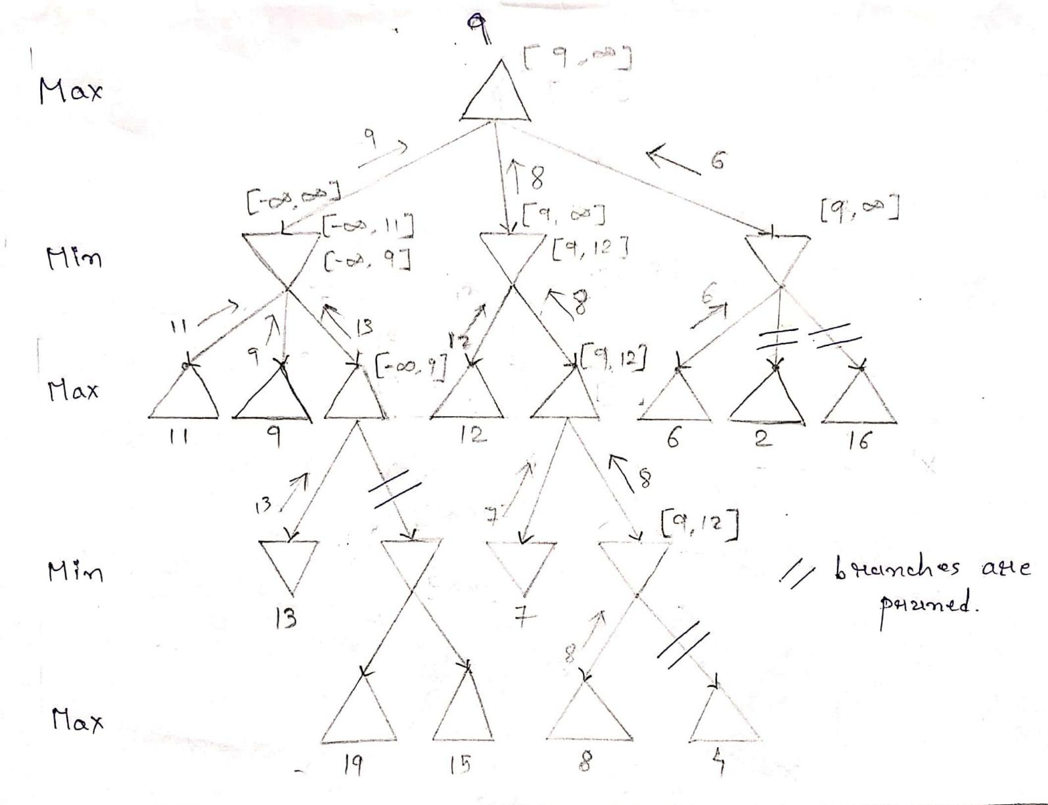

***Answer - 3***

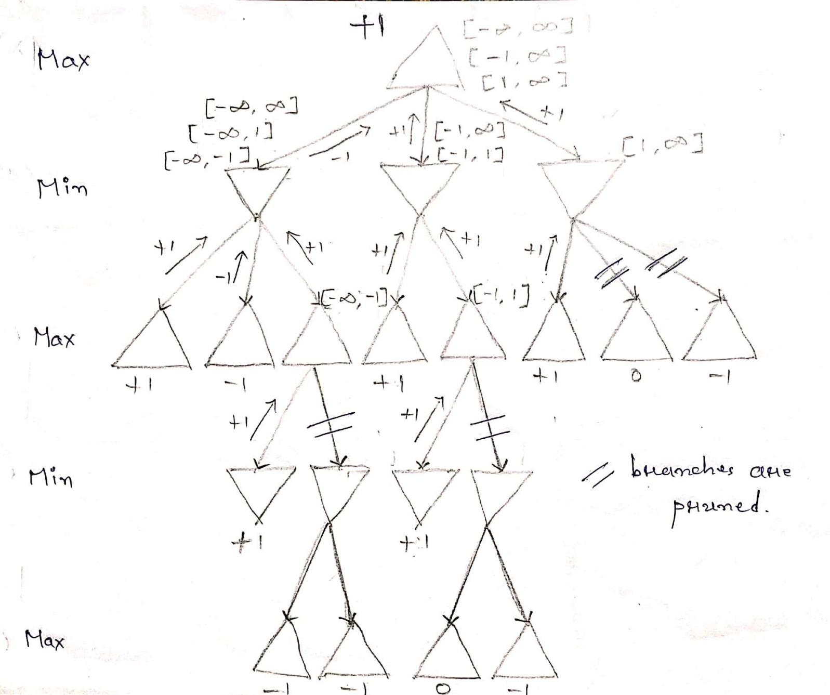

***Answer - 4***

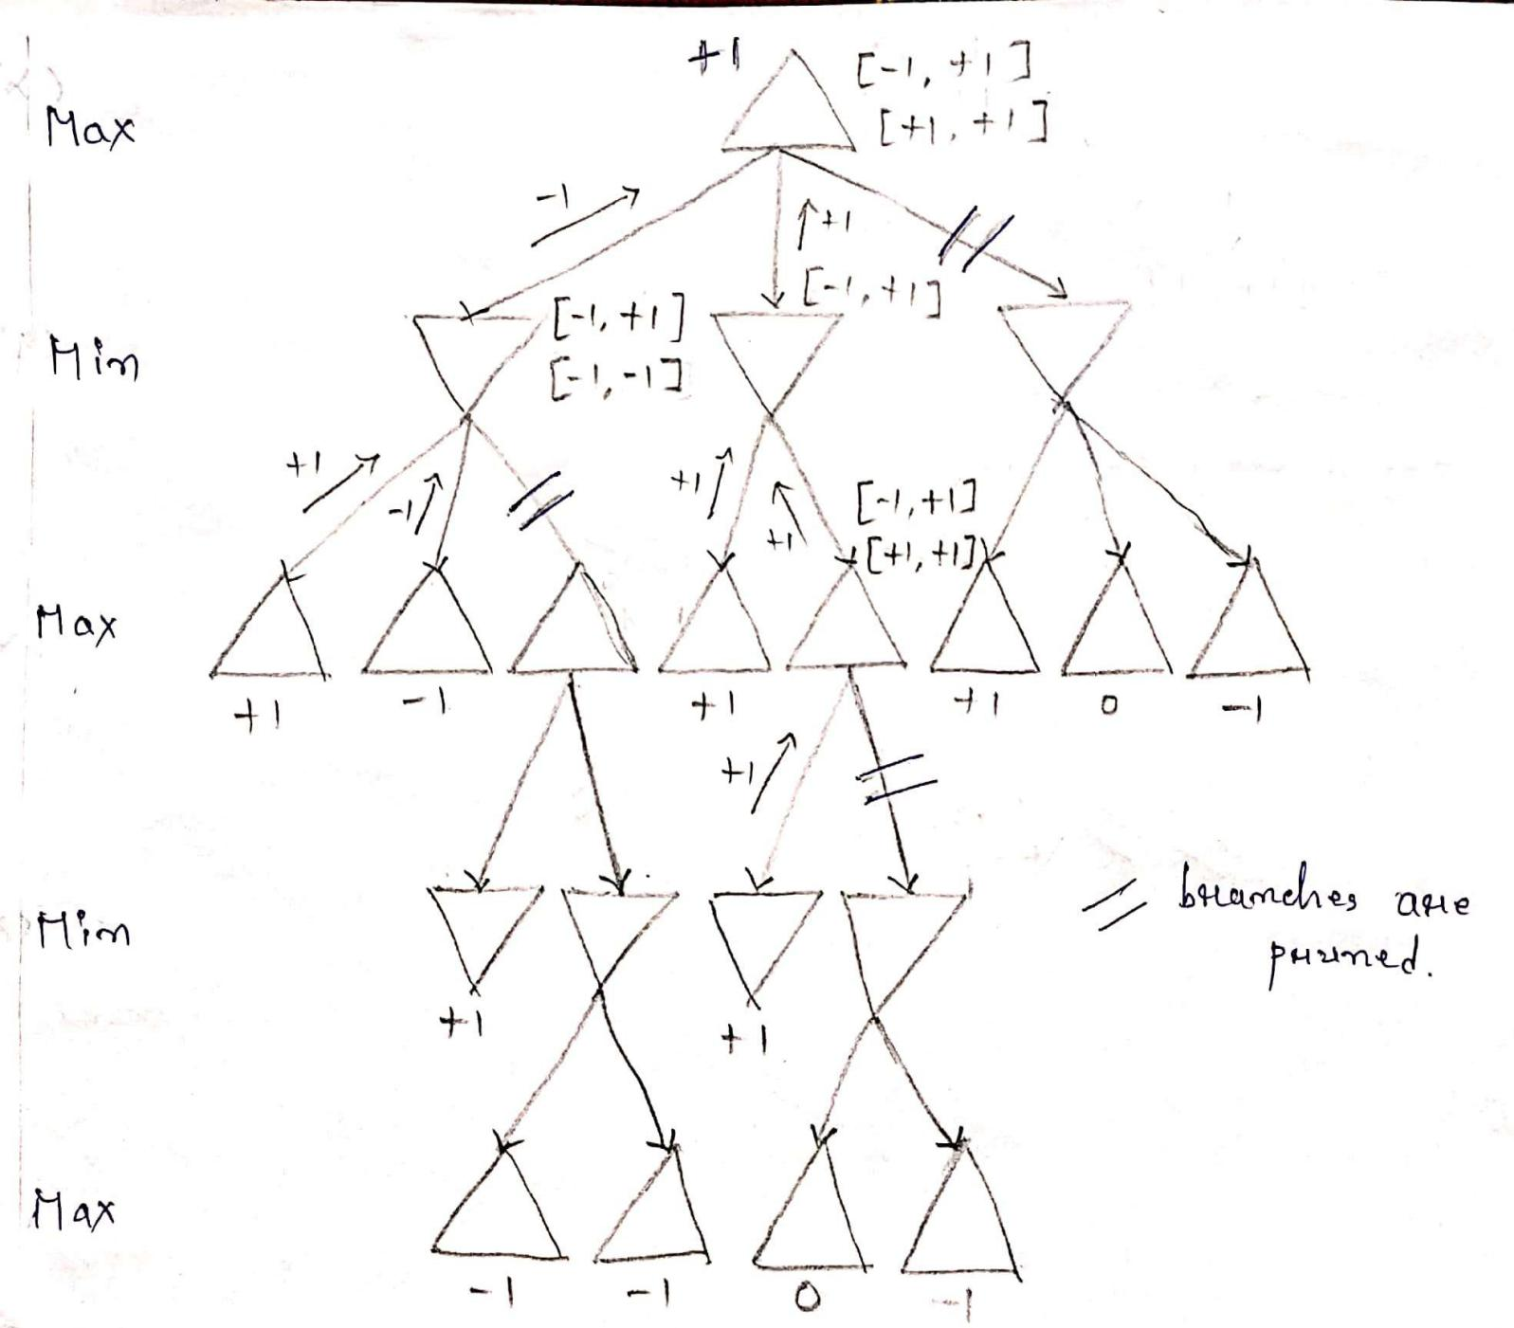

***Answer - 5***

